Route: a way to go some place
Example: I take the same route to work every day.
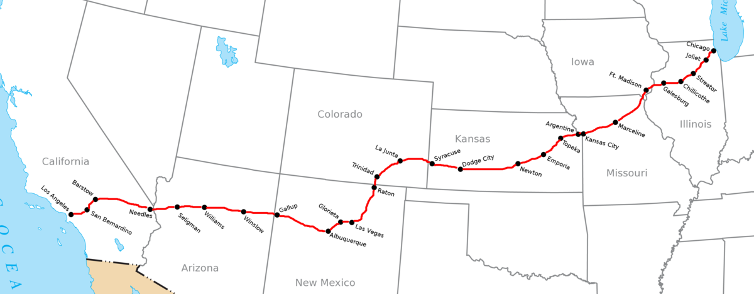

Prairies: large areas covered in grass
Example: Many farmers grow wheat and corn on prairies.
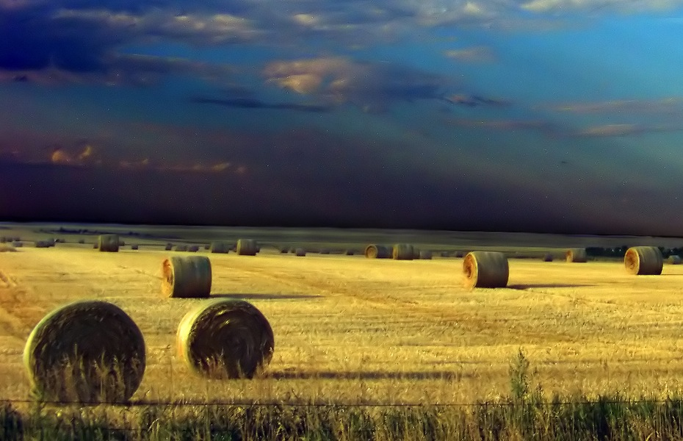

Canal: a waterway that links bodies of water together, and is built by people
Example: The Soo Canal is between Lake Superior and Lake Huron.
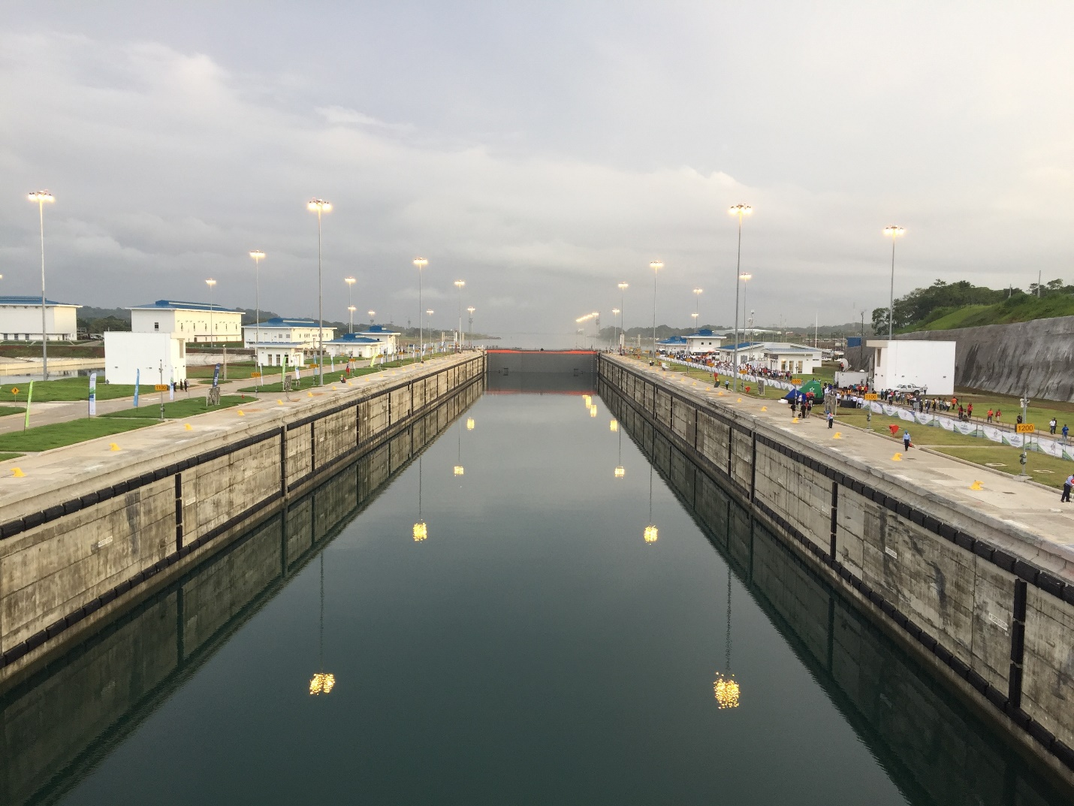
Pioneers: people who go to live in a new place
Example: Many pioneers moved to the plains of the Midwest in the 1880s.
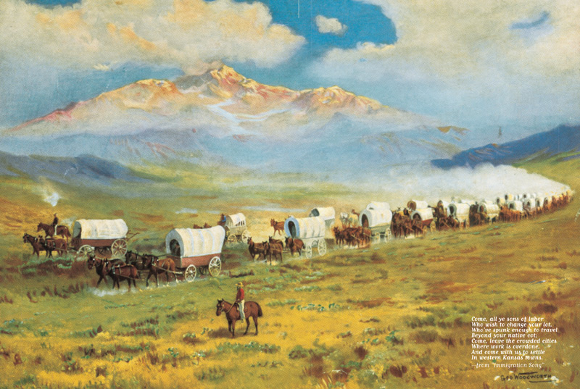

Homesteading: the government gave land to people who built a farm
Example: Some people moved in the 1880s because of homesteading.
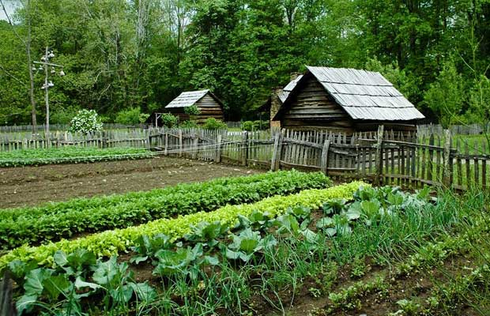
Sod: blocks of dirt with grass growing in it
Example: Some people used to build homes from sod.
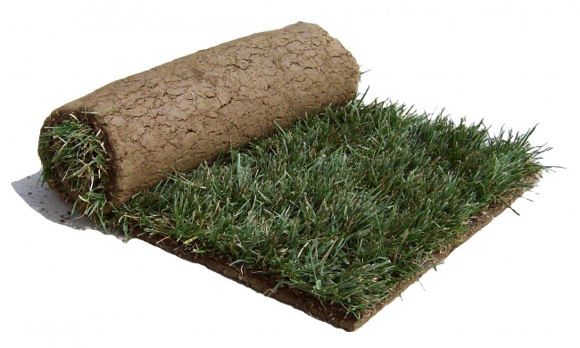
Population: the number of people who live in a place
Example: The population of the Midwest is over 64 million people.
Assembly line: each worker does the same job over and over again
Example: Cars are made on an assembly line.
